Monday | Due: 10/4 |  | Due: 10/4  All Contract work due Monday
 | Vocabulary/  Wordly Wise | Packet  Sentences  Wordly Wise is due every 2 weeks | Due Date:__________  LESSON 4  DUE: 9/30  Test: 9/30
 | Novel Study | Novel:  Read | Epic.com when finished with everything
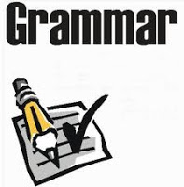 | Grammar | Canvas | No Red INK=  Pronouns in Sentences
 | Text book, Common Lit or  Close Reader  Short Story or  Non Fiction or article | Read: p-  Answer questions  Complete Vocabulary | BATS-  Close Reader p.29  How Smart Are Animals? P. 105
 | Poetry | Complete poetry task  2.) answer questions | The Last Wolf- P. 102  Collections Textbook.
 | Writing | Complete Writing
 | Current events/  News ELA  Chose article on NEWSELA.com |  | Current Event  News ELA  Use transitions words  and phrases
Due: Monday | Due:  Monday

