Mountain ridge high school

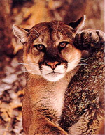
English Language Arts 1-2 Honors Summer Reading Packet Due Fri., Aug. 9, 2019
Mrs. Moya & Mrs. Aspaas
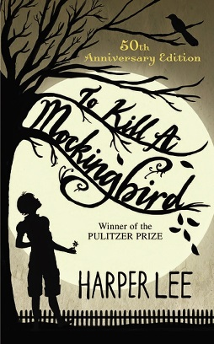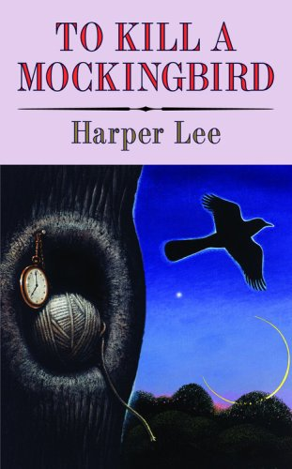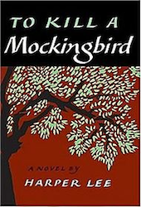
To Kill a Mockingbird
by Harper Lee

1. Obtain a copy of To Kill a Mockingbird by Harper Lee. We recommend purchasing your own copy to read and then use during the unit beginning in August however, you may check one out from a library as well.
2. Your answers must be TYPED in a 12 point, plain font.
3. Only hard copies of your answers will be accepted, so please remember to print out your answers and bring them to school on Fri., Aug. 9th. Your teacher WILL NOT print it for you.
4. During the first week of school, you will submit your assignment to turnitin.com. Your teacher will show you how to do this. To prepare for that, you will need your own email address. If you don’t have one, please create one over the summer.
There will be a test during the first week of school!
Questions? Visit one of our websites which can be accessed from the Mountain Ridge High School Website. Go to Staff Websites and click on the teacher’s name or email Heidi.moya@dvusd.org or natalie.aspaas@dvusd.org
Literary Terms.
Study this list of terms. You will be looking for examples of these throughout To Kill a Mockingbird. If you are struggling to understand how these are used in literature, look up examples online for assistance.
Stretch your brain! Include at least 10 of these between both of your quote charts. If you use an element more than 3 times, you will have points deducted.
Figurative Language
Hyperbole - An exaggeration that is so dramatic that no one would believe the statement is true. Tall tales are hyperboles. Example: I’m so hungry I could eat a horse.
Idiom - An idiom is an expression that has a meaning apart from the meanings of its individual words. It’s not meant to be taken literally. Example: It’s raining cats and dogs.
Irony – Irony is a literary device involving a discrepancy between what is said and what is meant, or between what’s expected to happen and what actually occurs. There are three main types:
- Dramatic irony - A situation in which the audience knows something about present or future circumstances that the character does not know.
- Verbal irony - A contradiction of expectation between what is said and what is meant.
- Situational irony - A contradiction between what might be expected and what actually occurs. It’s often connected to a really negative view of life.

Metaphor - The metaphor makes a direct comparison between two unlike things. A simile would say you are like something; a metaphor is more positive - it says you are something. Example: Her eyes are stars shining in the sky.
Personification - A figure of speech in which human characteristics are given to an animal or an object. Example: My teddy bear gave me a hug.
Pun – A play on words. A pun involves using a word or words that have more than one meaning.
Example: My dog not only has a fur coat, but also pants.
Simile - A simile uses the words “like” or “as” to compare one object or idea with another to suggest they are alike.
Example: She is busy as a bee.
Theme - A theme is a main universal idea or message conveyed by story. A theme is expressed as a complete sentence.
Example: Little Red Riding Hood's theme may be "Don't talk to strangers".
Mood - Mood refers to the general sense or feeling the reader is supposed to get from the story. Mood doesn’t refer to a characters' state of mind. It’s how we feel when we read a story.
Tone – Tone is the attitude a writer has towards what they're writing about. Authors show tone through their word choice, style, and opinion if they express one. It’s how the author feels when writing a story.
Point of View – Point of View is the perspective from which the reader sees the story. It may be first person (there is no narrator and the story is told by one of the characters as events unfold) or third person (the story is told by an observer of the story. This could be someone who may or may not be involved).
Common Literary Techniques
Allusion A reference in a work of literature to something outside the work, especially to a well-known historical or literary event, person, or work.
Example: The title of John Steinbeck’s book, Of Mice and Men is an allusion to a line from a poem by Robert Burns.
Foil - A foil is a character who is meant to represent characteristics, values or ideas which are opposite to another character (usually the protagonist). Example: Mercutio is Romeo’s foil in Romeo & Juliet.
Foreshadowing - Where future events in a story, or perhaps the outcome, are suggested by the author before they happen. This suggestion can be made in various ways such as a flashback, an object, or a previous situation which reflects a more significant situation later on.
Imagery – Imagery is the sensory details and images evoked by the words of a story. When you are asked to discuss the images or imagery of a work, you should look especially carefully at the sensory details and the metaphors and similes of a passage.
Parallelism - The use of similar or identical language, structures, events or ideas in different parts of a text.
Symbolism - A symbol is an object, color, person, character or figure used to represent abstract ideas. A symbol must be visible. Symbols exist all around us in “real” life, like a heart () used to represent “love”.
Examples: Cars are symbolic in The Outsiders. They represent the social mobility the Soc’s have that the Greasers don’t (they also are an example of situational irony because Darry and Soda work on cars, and know more about them than the Greasers who drive them).
__________________________________________________________________________________________________
Microthemes
Microthemes are “mini” essays. Usually 8-12 sentences in length, the purpose of a microtheme is to capture information about a topic in a concise way that includes analysis with textual evidence while maintaining 3rd person point of view.
Microthemes include:
1. A thesis statement.
2. Sentences of facts/examples from the book along with your opinion/analysis of those facts/examples.
3. A concluding sentence.
You will write a total of 2 microthemes, one per chart. Please type the microthemes together after both charts and indicate which chart the microtheme matches. Address the prompt below for each chart:
In a well written, 8-12 sentence microtheme, explain the importance and literary significance of one quote from your chart. Include the quote in your microtheme with the correct citation.

To Kill a Mockingbird Part One, Chapters 1-11 Name___________________
Directions: For Part One, choose one quote per chapter. Write the quote including the page #, explain the importance of the quote and how the quote helps to show a particular literary device. Use the literary terms list to help you.
Ch | Quote with page # | Importance | Connection to literary term
1
2
3
4
5
6
7
8
9
10
11

To Kill a Mockingbird Part Two, Chapters 12-31 Name_____________________
Directions: For Part Two, choose one quote per chapter. Write the quote including the page #, explain the importance of the quote and how the quote helps to show a particular literary device. *Some chapters in this section are short. You can still find quotes from those chapters to analyze on your chart. Use the literary terms list to help you.
Ch | Quote with page # | Importance | Connection to literary term
12
13
14
15
16
17
18
19
20
21
22
23
24
25

26

27

28

29

30

31

